**Sample Programs Analysis**

1. Total number of training project：153
2. Total count number of training project (have warnings)：118
3. Project without warnings:
   1. ans
   2. b+tree
   3. babelstream
   4. bitonic
   5. cfd
   6. che
   7. clink
   8. cobahh
   9. crc64
   10. divergence
   11. dwt
   12. libor
   13. lid-driven-cavity
   14. lombscargle
   15. lud
   16. mandelbrot
   17. matrix-mul
   18. matrix-remote
   19. metropolis
   20. miniFE
   21. miniWeather
   22. minimap2
   23. minray
   24. mixbench
   25. Mkl-segmm
   26. Particle-diffusion
   27. Particlefilter
   28. Projectile
   29. randomAccess56
   30. Results
   31. Rsbench
   32. Scan2
   33. Secp256k1
   34. Shmembench
   35. Shuffle
   36. Sort
   37. Streamcluster
   38. Cu3
   39. Sw4lite
   40. traid
   41. Urng
   42. xsbench
4. Total number of warning: 788
5. The number of types of warnings: 15

Sort by warning type：

|  |  |  |
| --- | --- | --- |
|  | Warning type | numbers |
| 1 | 1000 | 9 |
| 2 | 1001 | 9 |
| 3 | 1003 | 154 |
| 4 | 1004 | 3 |
| 5 | 1007 | 3 |
| 6 | 1008 | 21 |
| 7 | 1009 | 2 |
| 8 | 1010 | 9 |
| 9 | 1011 | 20 |
| 10 | 1013 | 31 |
| 11 | 1017 | 2 |
| 12 | 1032 | 8 |
| 13 | 1039 | 37 |
| 14 | 1049 | 255 |
| 15 | 1065 | 225 |
|  | SUM | 788 |

Sort by warning number：

|  |  |  |
| --- | --- | --- |
|  | Warning type | numbers |
| 1 | 1049 | 255 |
| 2 | 1065 | 225 |
| 3 | 1003 | 154 |
| 4 | 1039 | 37 |
| 5 | 1013 | 31 |
| 6 | 1008 | 21 |
| 7 | 1011 | 20 |
| 8 | 1000 | 9 |
| 9 | 1001 | 9 |
| 10 | 1010 | 9 |
| 11 | 1032 | 8 |
| 12 | 1004 | 3 |
| 13 | 1007 | 3 |
| 14 | 1017 | 2 |
| 15 | 1009 | 2 |
|  | SUM | 788 |

1. Warning location and number:

Brief form：

|  |  |  |  |  |
| --- | --- | --- | --- | --- |
|  | Warning type | Occurrence numbers | Number of documents | Average |
| 1 | 1049 | 255 | 95 | 2.68 |
| 2 | 1065 | 225 | 49 | 4.59 |
| 3 | 1003 | 154 | 11 | 14 |
| 4 | 1039 | 37 | 11 | 3.36 |
| 5 | 1013 | 31 | 1 | 31 |
| 6 | 1008 | 21 | 7 | 3 |
| 7 | 1011 | 20 | 3 | 6.6 |
| 8 | 1000 | 9 | 5 | 1.8 |
| 9 | 1001 | 9 | 5 | 1.8 |
| 10 | 1010 | 9 | 7 | 1.28 |
| 11 | 1032 | 8 | 1 | 8 |
| 12 | 1004 | 3 | 1 | 3 |
| 13 | 1007 | 3 | 2 | 1.5 |
| 14 | 1017 | 2 | 1 | 2 |
| 15 | 1009 | 2 | 2 | 1 |

Detail form：

|  |  |  |  |  |  |  |
| --- | --- | --- | --- | --- | --- | --- |
|  | Warning type | Warning message | Occurrence numbers | Number of documents | Occurrence project (location) [Occurance number] | Average |
| 1 | 1049 | The workgroup size passed to the SYCL kernel may exceed the limit. To get the device limit, query info::device::max_work_group_size. Adjust the workgroup size if needed. | 255 | 95 | Myocyte (master.dp.cpp: 59)[1]；  maxpool3d (main.dp.cpp: 99)[1]；  Sph (fluid.dp.cpp: 500, 514, 528, 543)[4]；  inversek2j (main.dp.cpp: 284) [1]；  Bn (main.dp.cpp: 104)[1];  Popcount (main.dp.cpp: 154, 171, 188, 205, 222)[5];  Dslash (kernels.dp.cpp: 191)[1];  Knn (main.dp.cpp: 284, 340, 367)[3];  Minimod (minimig.dp.cpp: 300, 349, 398, 447, 496, 545, 594)[7];  Sosfil (main.dp.cpp: 223)[1];  Radixsort (RadixSort.dp.cpp: 36, 70, 105; Scan.dp.cpp: 29, 60, 86)[6];  Gd (main.dp.cpp: 180, 195, 220)[3];  Sobol (sobol_gpu.dp.cpp: 197)[1];  Bsw (driver.dp.cpp: 201, 282)[2];  Gmm (cluster.dp.cpp: 873, 928)[2];  Extrema (main.dp.cpp: 234, 290)[2];  Laplace (main.dp.cpp: 317, 339)[2];  Nn (nearestNeighbor.dp.cpp: 87)[1];  Minisweep (main.dp.cpp: 306, 328, 349, 370)[4];  Asta (main.dp.cpp: 322)[1];  Gaussian (gaussianElim.dp.cpp: 239, 252)[2];  black-scholes (blackScholesAnalyticEngine.dp.cpp: 255)[1];  Md (MD.dp.cpp: 215, 243)[2];  heartwall (kernel/kernel.dp.cpp: 459) [1]  Backprop (main.dp.cpp: 92, 145)[2];  Mdh (main.dp.cpp: 285, 304) [2];  Amgmk (main.dp.cpp: 304)[1];  Present (main.dp.cpp: 560)[1];  Geodesic (main.dp.cpp: 164)[1];  Heat (heat.dp.cpp: 147, 160, 205)[3];  Pathfinder (main.dp.cpp: 260) [1];  rtm8 (rtm8.dp.cpp: 198)[1];  Mt (MT.dp.cpp: 172, 186)[2];  Dp (main.dp.cpp: 84)[1];  Clenergy (clenergy.dp.cpp: 262)[1];  Snake (main.dp.cpp: 424)[1];  page-rank (main.dp.cpp: 236, 251)[2];  atomicIntrinsics (main.dp.cpp: 154)[1];  all-pairs-distance (main.dp.cpp: 271)[2];  Thomas (main.dp.cpp: 153)[1];  Deredundancy (main.dp.cpp: 48, 70, 108, 123, 138, 153, 174, 206, 256, 270, 283, 302, 316)[13];  s3d (S3D.dp.cpp: 305, 319, 333, 348, 362, 376, 390, 404, 418, 432, 446, 460, 475, 489, 503, 516, 530, 543, 556, 570, 584, 598, 612, 626, 640, 654, 668)[27];  Hybridsort (mergesort.dp.cpp: 196, 239; bucketwort.dp.cpp: 69, 148)[4];  Hmm (ViterbiGPU.dp.cpp: 94)[1];  Sssp (main.dp.cpp: 650)[1];  easyWave (main.dp.cpp: 895, 918)[2];  Haccmk (haccmk.dp.cpp: 98)[1];  Srad (main.dp.cpp: 296, 325, 350, 409, 425, 450)[6];  hotspot3D (3D.dp.cpp: 169)[1];  Jaccard (main.dp.cpp: 261, 278, 299, 327, 356)[5];  epistatis (main.dp.cpp: 332)[1];  Boxfilter (main.dp.cpp: 192, 218)[2];  Fpc (main.dp.cpp: 281, 319)[2];  Multimaterial (compact.dp.cpp: 364, 382, 409, 429, 455)[5];  convolutionSeparable (conv.dp.cpp: 145, 186)[2];  lid-driven-cavity (main.dp.cpp: 983, 994, 1007, 1047, 1059, 1076, 1093, 1110, 1150, 1169, 1202)[11];  heat2d (main.dp.cpp: 142)[1];  Qtclustering (QTC.dp.cpp: 274, 341, 409, 467)[4];  Nw (nw.dp.cpp: 390, 422)[2];  Nms (main.dp.cpp: 290, 315)[2];  Ss (main.dp.cpp: 203, 242)[2];  b+tree (kernel2_wrapper.dp.cpp: 127; kernel_wrapper.dp.cpp: 120)  Kmeans (cluster.dp.cpp: 116, 190)[2];  Ldpc (main.dp.cpp: 243, 260, 288, 305)[4];  rng-wallace (main.dp.cpp: 53)[1];  Floydwarshall (main.dp.cpp: 246)[1];  Softmax (main.dp.cpp: 77)[1];  compute-score (main.dp.cpp: 438, 462)[2];  Libor (main.dp.cpp: 359, 386)[2];  Particles (bitonicSort.dp.cpp: 65, 94, 128, 153; particles.dp.cpp: 37, 58, 81, 109, 141)[9];  Minibude (main.dp.cpp: 286, 304)[2];  Medianfilter (main.dp.cpp: 140)[1];  Lulesh (lulesh.dp.cpp: 2571, 2588, 2602, 2614, 2713, 2728, 2768, 2815, 2832, 2895, 2914, 2950, 2994, 3067)[14]  jenkins-hash (main.dp.cpp: 284)[1]  Bfs (bfs.dp.cpp: 159, 175)[2]  recursiveGaussian (main.dp.cpp: 293, 317, 344, 368)[4]  Winograd (main.dp.cpp: 161)[1]  Reduction (reduction.dp.cpp: 207, 243, 278, 313, 347)[5]  murmurhash3 (murmurhash3.dp.cpp: 212)[1]  Lombscargle (main.dp.cpp: 195)[1]  Sampling (kernels.dp.cpp: 190, 211)[2]  Nbody (GSimulation.dp.cpp: 133)[1]  bezier-surface (main.dp.cpp: 282)[1]  Qrg (main.dp.cpp: 167, 195)[2]  md5hash (MD5Hash.dp.cpp: 430)[1]  d2q9-bgk (main.dp.cpp: 458)[1]  Filter (main.dp.cpp: 111)[1]  Flame (main.dp.cpp: 180, 198, 216)[3]  fdtd3d (FDTD3dGPU.dp.cpp: 196)[1]  Simplemoc (main.dp.cpp: 564)[1]  dct8x8 (kernels.dp.cpp: 187, 207)[2]  testSNAP (main.dp.cpp: 867, 882, 898, 923, 938, 962, 987)[7]  bspline-vgh (main.dp.cpp: 255)[1]  Affine (main.dp.cpp: 269)[1]  Diamond (masking.dp.cpp: 307)[1]  iso2dfd (iso2dfd.dp.cpp: 266, 280)[2]  chi2 (chi2.dp.cpp: 296)[1] | 2.68 |
| 2 | 1065 | Consider replacing sycl::nd_item::barrier() with sycl::nd_item::barrier(sycl::access::fence_space::local_space) for better performance, if there is no access to global memory. | 225 | 49 | Bn (kernels.dp.cpp: 152, 178, 186, 206)[4];  Axhelm (axhelmKernels.cpp.dp.cpp: 47, 59, 76, 89, 154, 173, 205)[7];  Knn (main.dp.cpp: 86, 104)[2];  Minimod (mining.dp.cpp: 55, 144; find_min_max.dp.cpp: 24, 45)[4];  Sosfil (main.dp.cpp: 67, 99, 129, 156)[4]  Radixsort (Scan_kernels.dp.cpp: 52, 59, 246; RadixSort_kernels.dp.cpp: 61, 72, 82, 111, 145, 173, 186, 247, 262, 273, 297, 366)[15]  Sobol (sobol_gpu.dp.cpp: 70)[1]  Bsw (kernel.dp.cpp: 107, 119, 139, 153, 175, 187, 207, 221, 330, 364, 410, 477, 484, 597, 632, 676, 750, 757, 780)[19]  Gmm (gaussian_kernel.dp.cpp: 56, 151, 167, 194, 212, 225, 269, 287, 300, 315, 332, 386, 408, 423, 466, 475, 481, 551, 642, 679, 723, 787, 815, 830, 864, 892, 930, 940)[28]  Asta (main.dp.cpp: 70, 89, 122, 153, 196)[5]  Transpose (main.dp.cpp: 70, 91)[2]  Mdh (main.dp.cpp: 99, 129, 178, 207)[4]  Clock (main.dp.cpp: 57, 79)[2]  Bsearch (main.dp.cpp: 89)[1]  Pathfinder (main.dp.cpp: 97, 133, 152)[3]  Scan (main.dp.cpp: 22, 41)[2]  Lanczos (lanczos.dp.cpp: 41, 54)[2]  all-pairs-distance (main.dp.cpp: 101, 131)[2]  Deredundancy (kernels.dp.cpp: 502)[1]  Sssp (main.dp.cpp: 222, 246, 258, 268, 359, 379)[6]  Srad (reduce_kernel.dp.cpp: 37, 55, 80, 109)[4]  Grep (pnfa.dp.cpp: 232)[1]  Reverse (main.dp.cpp: 13)[1]  Boxfilter (main.dp.cpp: 83)[1]  Fpc (main.dp.cpp: 166, 176, 238, 248)[4]  convolutionSeparable (conv.dp.cpp: 62, 113)[2]  lid-driven-cavity (main.dp.cpp: 363, 377, 570, 584, 660, 675, 773, 788)[8]  dxtc1 (main.dp.cpp: 43, 57; kernel.dp.cpp: 498, 517, 553)[5]  Nw (nw.dp.cpp: 107, 117, 126, 135, 151, 159, 179, 218, 227, 236, 254, 274)[12]  Nms (main.dp.cpp: 66)[1]  Ss (kernels.dp.cpp: 92, 111, 182, 213, 220, 259, 266, 306)[8]  b+tree (kernel2.dp.cpp: 43, 44, 67; kernel.dp.cpp: 35, 46)[5]  Lud (lud_kernels.dp.cpp: 16, 31, 54, 98, 120, 165)[6]  Ldpc (kernel.dp.cpp: 212)[1]  Rgn-wallace (wallace_kernel.dp.cpp: 60, 84, 106, 131, 152, 163)[6]  Ced (main.dp.cpp: 107, 182, 292)[3]  Compute-score (main.dp.cpp: 324)[1]  Particles (particles_kernels.dp.cpp: 316; bitonicSort_kernels.dp.cpp: 79, 97, 112, 168, 189, 205, 295, 310)[9]  Minibude (kernel.dp.cpp: 85)[1]  Medianfilter (MedianFilter.dp.cpp: 153)[1]  recursiveGaussian (main.dp.cpp: 69)[1]  Sampling (kernels.dp.cpp: 123)[1]  d2q9-bgk (main.dp.cpp: 310)[1]  Vmc (vmc.dp.cpp: 82, 100)[2]  Filter (main.dp.cpp: 31, 49, 65, 77)[4]  Stencil (stencil_1d.dp.cpp: 37)[1]  fdtd3d (FDTD3dGPU.dp.cpp: 121)[2]  Split (main.dp.cpp: 65, 76, 86, 115, 146, 174, 187)[7]  Tridiagonal (pcr_kernels.dp.cpp: 59, 134, 147, 179, 221, 262, 275, 307; sweep_kernels.dp.cpp: 534; cyclic_kernels.dp.cpp: 66, 76, 166, 203, 253, 263, 334, 371)[17] | 4.59 |
| 3 | 1003 | Migrated API does not return error code. (*, 0) is inserted. You may need to rewrite this code. | 154 | 11 | inversek2j (main.dp.cpp: 298)[1];  Gmm (cluster.dp.cpp: 262, 267, 272, 277, 282, 287, 292, 297, 327, 332, 337, 343, 349, 356, 365, 374, 386, 393, 413, 419, 425, 431, 439, 447, 456, 466, 487, 493, 499, 507, 515, 524, 534, 624, 630, 637, 644, 761, 818, 861, 891, 914, 959, 997, 1037, 1092, 1119, 1209, 1214, 1219, 1224)[51];  Quicksort (main.dp.cpp: 169, 176, 182, 189, 198, 207, 255, 260, 269, 274, 279, 312, 319, 385, 392)[15];  Heat (heat.dp.cpp: 175, 231)[2];  Memcpy (main.dp.cpp: 41)[1];  s3d (S3D.dp.cpp: 127, 133, 139, 146, 153, 197, 203, 209, 216, 223, 230, 237, 244, 251, 258, 265, 280, 285, 290, 295, 684, 693, 698, 703, 708, 713, 718, 723, 728, 733, 738, 743, 758, 763, 768, 773, 778)[37];  Ising (main.dp.cpp: 249, 259, 266, 314, 330, 350, 358)[7];  Nms (main.dp.cpp: 217, 223, 232, 242, 250, 260, 269, 336)[8];  Aobench (ao.dp.cpp: 365, 372, 377, 401)[4];  Vmc (vmc.dp.cpp: 270, 275, 280, 285, 290, 295, 300, 305, 310, 316, 322, 407, 439, 444, 449, 454, 459, 464, 469, 474, 479, 484, 489)[23];  chi2 (chi2.dp.cpp: 165, 220, 242, 266, 313)[5] | 14 |
| 4 | 1039 | The generated code assumes that <parameter name> points to the global memory address space. If it points to a local memory address space, replace <function name> with <function name>. | 37 | 11 | Gd (main.dp.cpp: 17, 51, 62, 76)[4];  Minisweep (kernels.dp.cpp: 342)[1];  Asta (main.dp.cpp: 63, 81, 113, 145, 189)[5];  ccsd-trpdrv (ccsd_tengy.dp.cpp: 56, 71, 94, 107)[4];  all-pairs-distance (main.dp.cpp: 68)[1];  Sssp (main.dp.cpp: 181, 190, 198, 214, 236, 280, 288, 310, 321, 348, 370, 395)[12];  Jaccard (main.dp.cpp: 164)[1];  Fpc (main.dp.cpp: 183, 255)[2];  randomAccess (main.dp.cpp: 79)[1];  Reduction (reduction.dp.cpp: 72, 91, 110, 128, 148)[5];  Filter (main.dp.cpp: 58)[1] ; | 3.36 |
| 5 | 1013 | The rounding mode could not be specified and the generated code may have different precision then the original code. Verify the correctness. SYCL math built-ins rounding mode is aligned with OpenCL C 1.2 standard. | 31 | 1 | Tridiagonal (pcr_kernels.dp.cpp: 76, 94, 113, 120, 164, 170, 243, 249, 292, 298; sweep_kernels.dp.cpp: 289, 296, 303, 310, 322, 329, 336, 343; cyclic_kernels.dp.cpp: 94, 113, 120, 146, 152, 182, 190, 281, 288, 314, 320, 350, 358)[31]; | 31 |
| 6 | 1008 | The clock function is not defined in the DPC++. This is a hardware-specific feature. Consult with your hardware vendor to find a replacement. | 21 | 7 | Bn (main.dp.cpp: 91, 123, 132, 154)[4];  Clock (main.dp.cpp: 42, 86)[2];  ccsd-trpdrv (main.dp.cpp: 140, 150)[2];  Memcpy (main.dp.cpp: 61, 71, 81, 91)[4];  Hybridsort (hybridsort: 119, 126, 142, 151, 171, 179)[6];  Aobench (ao.dp.cpp: 429, 438)[2];  Simplemoc (init.dp.cpp: 117)[1]; | 3 |
| 7 | 1011 | The tool detected overloaded operators for built-in vector types, which may conflict with the SYCL 1.2.1 standard operators (see 4.10.2.1 Vec interface). The tool inserted a namespace to avoid the conflict. Use SYCL 1.2.1 standard operators instead. | 20 | 3 | dxtc1 (kernel.dp.cpp: 17, 35, 51, 67, 83, 98)[6];  Particles (particles_kernels.dp.cpp: 14, 32, 48, 64, 80, 96, 111, 126) [8];  Tridiagonal (sweep_kernels.dp.cpp: 222, 238, 254, 270, 352, 367) [6]; | 6.6 |
| 8 | 1000 | An error handling if-stmt was detected but could not be rewritten. | 9 | 5 | inversek2j (main.dp.cpp: 303)[1];  Heat (heat.dp.cpp: 180, 236)[2];  Memcpy (main.dp.cpp: 46)[1]; reduction (reduction.dp.cpp: 43)[1];  chi2 (chi2.dp.cpp: 228, 249, 275, 321)[4] | 1.8 |
| 9 | 1001 | The statement could not be removed. | 9 | 5 | inversek2j (main.dp.cpp: 308)[1];  Heat (heat.dp.cpp: 184, 240)[2];  Memcpy (main.dp.cpp: 50)[1]; reduction (reduction.dp.cpp: 48)[1];  chi2 (chi2.dp.cpp: 234, 255, 281, 327)[4] | 1.8 |
| 10 | 1010 | SYCL uses exceptions to report errors and does not use error codes. The call was replaced with 0. You may need to rewrite this code. | 9 | 7 | Keccaktreehash (KeccakTreeGPU.dp.cpp: 24)[1];  Quicksort (main.dp.cpp: 249, 379)[2];  Clenergy (clenergy.dp.cpp: 19)[1];  Nms (main.dp.cpp: 302, 328)[2];  Aobench (ao.dp.cpp: 394)[1];  Reduction (reduction.dp.cpp: 38)[1];  Flame (utils.dp.cpp: 82)[1] | 1.28 |
| 11 | 1032 | A different random number generator is used. You may need to adjust the code. | 8 | 1 | Vmc (vmc.dp.cpp: 34, 40, 50, 166, 189, 209, 265, 326)[8] | 8 |
| 12 | 1004 | Compatible DPC++ code could not be generated. | 3 | 1 | dxtc1 (kernel.dp.cpp: 257, 261, 265)[3] | 3 |
| 13 | 1007 | Migration of this API is not supported by the Intel® DPC++ Compatibility Tool. | 3 | 2 | Sptrsv (sptrsv_syncfree.dp.cpp: 19, 32)[2];  Vmc (vmc.dp.cpp: 56)[1] | 1.5 |
| 14 | 1017 | The <DPC++ API name> call is used instead of the <CUDA API name> call. These two calls do not provide the same functionality. Check the potential precision and/or performance issues for the generated code | 2 | 1 | Lombscargle (main.dp.cpp: 72, 90) [2] | 2 |
| 15 | 1009 | SYCL uses exceptions to report errors and does not use error codes. The original code was commented out and a warning string was inserted. You may need to rewrite this code. | 2 | 2 | Clenergy (clenergy.dp.cpp: 23)[1];  Reduction (reduction.dp.cpp: 52)[1] | 1 |

<10

<30

<50

>50

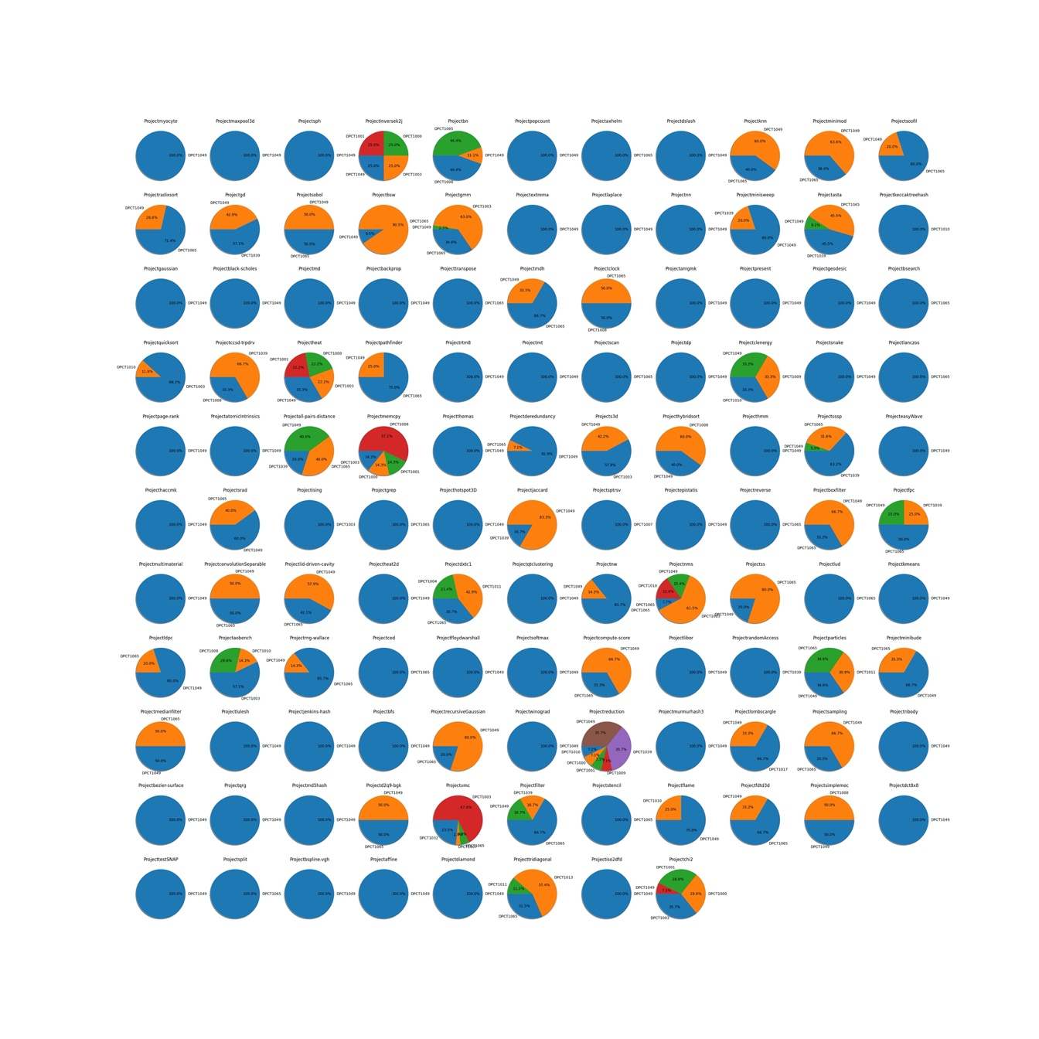

Top 2 graph analysis：

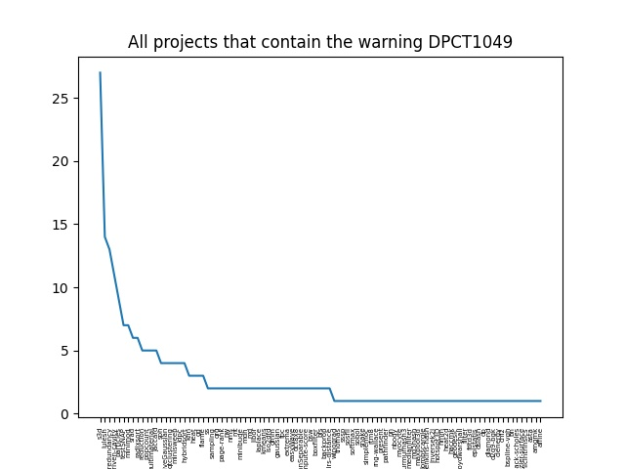

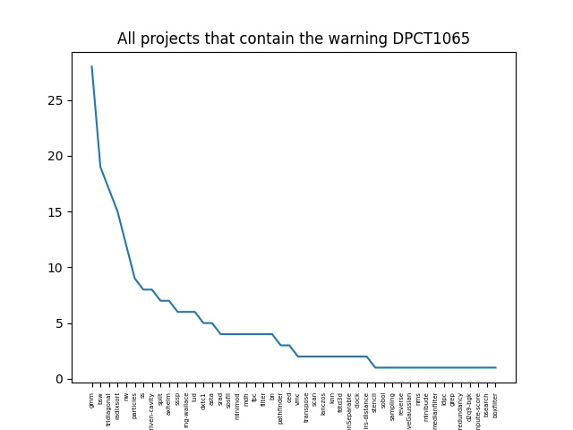

Can’t prove local warning